CT853 – Algorithms and Logical Methods Assignment

Jaqueline Cesca
Student ID 18231336
Abstract
This paper provides a briefly explanation of 4 topics: Merge Sort algorithms, Quick Sort algorithms, Fibonacci sequence and Exponentiation by squaring.
Question 1: Merge Sort
Explanation:
Merge sort works in two phases. On the first phase the array is recursively splitted until all the elements are represented by arrays of size 1. On the second phase (that happens when the function call is being unstacked), arrays are merged and sorted two by two, resulting on a sorted array. As the arrays to be ordered have only one element or are already ordered (as they came from another call to the same function), the sorting is simple. The ordering is done by comparing the first element of each array and moving the smaller one to the next position of the result array.
On my implementation there are 5 methods: main, readArrayFromConsole, breakArray, mergeSort and removeFirstElement. The main method drives the application execution calling readArrayFromConsole, showing the initial array, breaking and sorting the array and showing the final array. The breakArray method splits the array recursively, calling the mergeSort method. The mergeSort method merges two sorted arrays into one, moving the smaller of their first element to the next position of the result array. To do this move, the value is copied to the new array, and the first element of the array is removed. This last step is done using the removeFirstElement method.

Pseudocode:
BEGIN
PROCEDURE breakArray (myArray)
IF (size of myArray > 1)
integer size = size of myArray
integer newSize = size / 2
a1 = integer[newSize]
a2 = integer[size – newSize]

COPY first half of myArray to a1
COPY second half of myArray to a2

breakArray a1
breakArray a2

rstArray = mergeSort a1, a2
RETURN rstArray
ELSE
RETURN myArray
ENDIF
ENDPROCEDURE

PROCEDURE mergeSort (first, second)
rstArray = integer[size of first + size of second]
j = 0

WHILE (first or second has elements)
IF (first[0] < second[0])
rstArray[j] = first[0]
REMOVE first element of first
J = J + 1
ELSE
rstArray[j] = second[0]
REMOVE first element of second
J = J + 1
ENDIF
ENDWHILE

WHILE (first has elements)
rstArray[j] = first[0]
REMOVE first element of first
J = J + 1
ENDWHILE

WHILE (second has elements)
rstArray[j] = second[0]
REMOVE first element of second
J = J + 1
ENDWHILE
RETURN rstArray
ENDPROCEDURE
END

Graphic MergeSort:
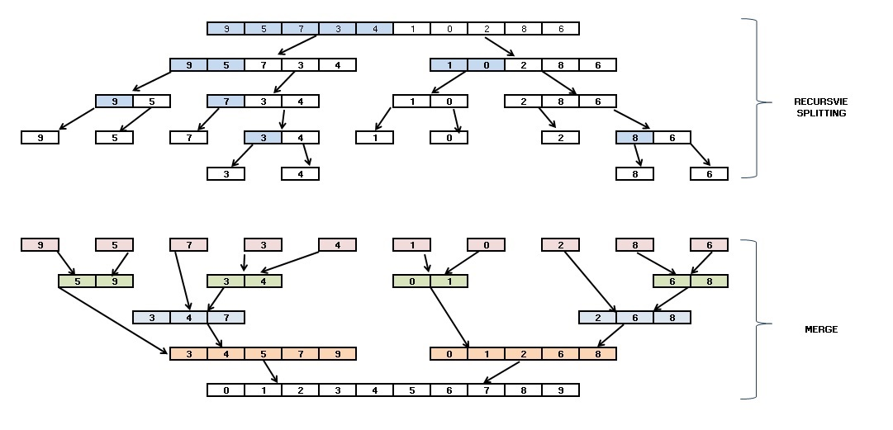

Question 2: Quick Sort
Explanation:
Quick Sort algorithm works using pivot and partitions. Different from MergeSort, Quick Sort order the elements while the functions are stacking. It starts creating two pointers to the left and right elements (or lower and upper). The algorithm starts comparing values between these two pointers. If the order between them is right (left is lower than right), one of the pointers move in direction to the other. If the order it wrong, both values are swapped, and the other pointer is the one that moves. When both left and right point to the same element, that element become the pivot and two new partitions of the array are created: lower than pivot and higher than pivot. The algorithm is called recursively for each partition of the array.
On my implementation there are 5 methods: main, readArrayFromConsole, quickSort, partition and swap. The main method drives the application execution calling readArrayFromConsole, showing the initial array, breaking and sorting the array and showing the final array. The quickSort method calls the partition method to get the pivot, calling itself again providing the new lower and upper (based on the pivot). The partition method compares the lower and upper pointers swapping when they are on the wrong order and moving them closer. When lower and upper point to the same element, this is chosen as a pivot and is returned by the function. The swap method executes the swap between two elements, step needed for the Quick Sort algorithm.

Pseudocode:
BEGIN
PROCEDURE quickSort(list, lower, upper)
IF (lower < upper)
pivot = partition(list, lower, upper)
quickSort(list, lower, pivot – 1)
quickSort(list, pivot + 1, upper)
ENDIF
ENDPROCEDURE

PROCEDURE partition(list, lower, upper)
WHILE (lower < upper)
WHILE (list[lower] < list[upper])
upper = upper - 1
ENDWHILE
swap(list, lower, upper)
IF (upper != lower)
lower = lower + 1
ENDIF
WHILE (list[lower] < list[upper])
lower = lower + 1
ENDWHILE
swap(list, lower, upper)
IF (upper != lower)
upper = upper - 1
ENDIF
ENDWHILE
ENDPROCEDURE
END
Graphic QuickSort:

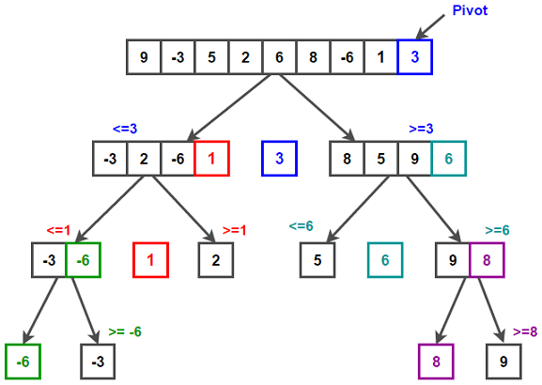

Question 3: Fibonacci

Explanation:
Fibonacci Sequence is a numeric sequence that always starts with 0 and 1, and the next number of the sequence is always the sum of the two previous ones. It’s not possible to predict an element of the sequence without knowing its predecessors.
My implementation was done in two ways: recursive and non-recursive.
On the recursive implementation (fibonacciRecursive) the method receives as input the last 2 elements and the number of elements to calculate. Once the new element is calculated, the method calls itself giving the new element and its predecessor as parameter, decreasing the number of elements to calculate. The stacking stops when there are no more elements to calculate. On each cycle, it prints the current element. On the first interaction it also prints the first 2 elements (0 and 1)
On the non-recursive implementation, the lastElement and beforeLastElement are stored in two variables. When the nextElement is calculated, the last element becomes the beforeLastElement and the nextElement becomes the lastElement; decreasing the number of elements to calculate. On each cycle, it prints the calculated element.
Pseudocode:
BEGIN
PROCEDURE fibonacciRecursive(beforeLastElement, lastElement, remaining)
IF (beforeLastElement = 0) AND (lastElement = 1)
PRINT 0 1
remaining = remaining - 2
ENDIF
nextElement = beforeLastElement + lastElement
PRINT nextElement
fibonacciRecursive(lastElement, nextElement, remaining – 1)
ENDPROCEDURE

PROCEDURE fibonacciNonRecursive(amount)
beforeLastElement = 0
lastElement = 1
PRINT 0 1
amount = amount – 2
WHILE (amount > 0)
nextElement = beforeLastElement + lastElement
PRINT nextElement
beforeLastElement = lastElement
lastElement = nextElement
amount = amount - 1
ENDWHILE
ENDPROCEDURE
END

Question 4: Exponentiation
Explanation:
Exponentiation by Squaring is a way to reduce exponentiation complexity calling the same method recursively. It’s based on the following rules, for x being the base and n being the power:
- If n = 0, result will be always 1 (independent of the base value).
- If n = 1, result will be always the value of the x.
- If n < 0, result will be the same as 1/x powered by |n|: expBySquaring(1 / x, n * -1)
- If n is even, result will be the same as (x * x) powered by (n / 2): expBySquaring(x * x, n / 2)
- If n is odd, result will be x * ((x * x) powered by ( (n - 1) / 2)): x * expBySquaring(x * x, (n – 1) / 2)
Pseudocode:
BEGIN
PROCEDURE expBySquaring(x, n)
IF (n = 0)
RETURN 1
ELSE
IF (n = 1)
RETURN x
ELSE
IF (n < 0)
RETURN expBySquaring(1 / x, n * -1)
ELSE
IF (n is even)
RETURN expBySquaring(x*x, n / 2)
ELSE
RETURN x * expBySquaring(x*x, (n – 1) / 2)
ENDIF
ENDIF
ENDIF
ENDIF
ENDPROCEDURE
END
References:
Enda Howley notes, week 1 to 6 for all questions;
MergeSort:
https://www.tutorialspoint.com/data_structures_algorithms/merge_sort_algorithm.htm
https://www.geeksforgeeks.org/merge-sort/
https://stackoverflow.com/questions/409784/whats-the-simplest-way-to-print-a-java-array
Graphic MergeSort:
https://www.google.ie/imgres?imgurl=https%3A%2F%2Fpythonandr.files.wordpress.com%2F2015%2F07%2Fmergesort1.jpg&imgrefurl=https%3A%2F%2Fpythonandr.com%2F2015%2F07%2F05%2Fthe-merge-sort-python-code%2F&docid=7B3x-IZfQRbbrM&tbnid=O5J3VRIraVg2tM%3A&vet=1&w=1081&h=521&bih=938&biw=1920&ved=0ahUKEwin-9Tqms3eAhXKCuwKHU3NBxcQMwh9KDAwMA&iact=c&ictx=1
QuickSort:
https://www.youtube.com/watch?v=h_9kAXFKJwY
Graphic QuickSort:
https://www.techiedelight.com/quicksort/

